**Traffic Impact Assessments (TIA) / Traffic Impact Study (TIS)**

BC HOUSING 1100 GLENFAIR DRIVE, KAMLOOPS

TRAFFIC IMPACT ASSESSMENT

|  |
| --- |
|  |

###### Project description

Faction Projects Inc. requested to complete a Traffic Impact Assessment (TIA) for the proposed development located at 1100 Glenfair Drive, Kamloops. The proposed development consists of senior adult housing, a potential city partnership area, and a commercial area. The objectives of this study were to:

* Analyze traffic data at the following study intersections:
  + Columbia Street / 5 Avenue intersection
  + Columbia Street / 6 Avenue intersection
* Investigate current traffic distribution at the study intersections during a.m. and p.m. peak hours;
* Determine and analyze the existing (2022) and project traffic volumes resulting from the development and evaluate the impacts on the study intersections during a.m. and p.m. peak hours under the full-build out year (2035) and 10-year planning horizon (2045).
* Review site access and circulation;
* Review alternate modes of transportation and the current infrastructure in the study area; and,
* Recommend development access modifications; if necessary.

|  |  |  |
| --- | --- | --- |
|  | 1503 Kingsway  Transportation Assessment and Management Study (TAMS) |  |

###### Project description

Cressey Development Group proposed a new mixed-used development at 1503 Kingsway, Vancouver, BC. The proposed development will be a 13-story residential/commercial building including 2 levels of underground parking.

As part of the Development Permit application, Cressey Development Group requested to prepare a Traffic Assessment and Management Study (TAMS) of the study area. The objectives of this study were to:

* Collect traffic counts at 22 Avenue/Fleming Street, 22 Avenue/Dumfries Street, 22 Avenue/Lanark Street, Kingsway/Knight Street, Fleming Street/Perry Street, Kingsway/Perry Street, East King Edward Avenue/Kingsway, and Kingsway/Dumfries Street intersections;
* Investigate the current traffic distribution at the study intersection during the AM and PM peak-hour periods using the newly obtained information;
* Determine and analyze the existing and projected traffic volumes resulting from the development, and evaluate their impacts on the study intersections for the AM and PM peak hours under the 2020 and 2030 planning horizon traffic conditions;
* Identify physical and operational mitigations required to offset network impacts from the development, including TAC signal warrant analysis where applicable, and an assessment of Kingsway and Dumfries Street intersection with and without a full signal, including potential left-turn bays and left-turn signal phasing; and,
* Review the parking bylaw requirements and the provisions of the planned development, including an AutoTurn assessment of vehicle maneuvering.

STS'AILES COMMUNITY CARE CLINIC

TRAFFIC IMPACT ASSESSMENT

The Sts’ailes First Nation and Keltic had requested to prepare a Traffic Impact Assessment (TIA) for the proposed development located at 46090 Lougheed Highway in Harrison Mills, BC. This TIA is prepared in collaboration with Ministry of Transportation and Infrastructure (MOTI) and Fraser Valley Regional District (FVRD). The project is proposed to be completed in two phases shown below:

* Phase 1: The Sts’ailes Community Care Clinic (SCCC): Expected to be completed in 2023;
* Phase 2a: Sts’ailes Elder Care Building: Expected to be completed in 2025;
* Phase 2b: The Ultimate Mixed Use Keltic Development: Expected to be completed in 2027;

The scope of this study included the following:

* Collect and analyze current traffic data at the following study intersections:
  + Lougheed Highway (Highway 7) / Beach Camp Road / Morris Valley Road;
  + Lougheed Highway (Highway 7) / Chehalis Forest Service Road / Beach Camp Road; and,
  + Lougheed Highway (Highway 7) / Chehalis Forest Service Road / Can Forest Products Road.
* Investigate current traffic distribution at the study intersection during a.m. and p.m. peak hours;
* Determine and analyze the projected traffic volumes resulting from the development and evaluate their impacts on the study intersections during the street a.m. and street p.m. peak hours under the horizon years detailed below;
* Analyze the impacts of the Lougheed Highway (Highway 7) / Chehalis Forest Service Road / Can Forest Products Road intersection (Can Forest Products Road intersection) closure (as an alternative option) under the 15-Year Planning Horizon (2042) for the post-development scenario only;
* Review development access points to ensure ingress and egress operate efficiently;
* If required, identify and recommend appropriate infrastructure improvements necessary to accommodate the estimated traffic volumes; and,

**804 Innes Avenue, Traffic Impact Study**

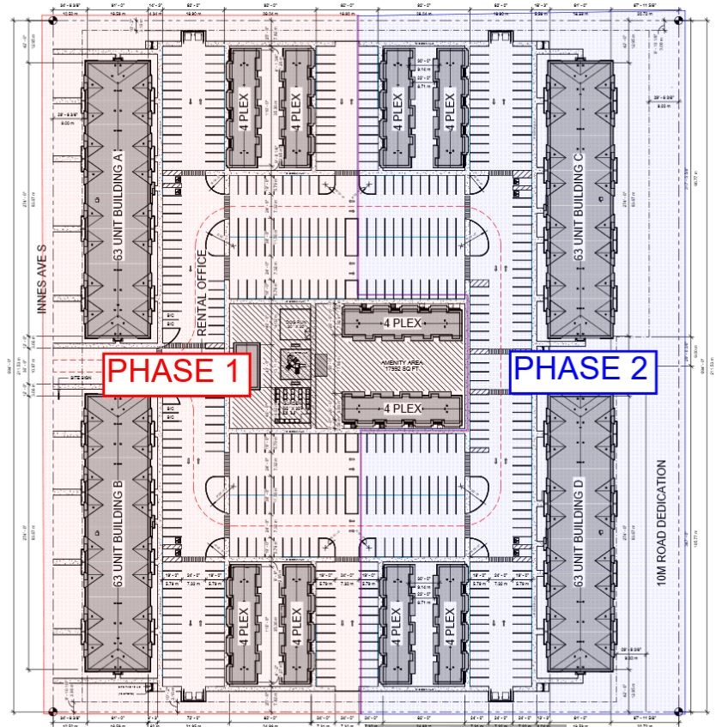

Broadstreet Properties Ltd./Seymour Pacific Developments Ltd. propsoed to a build 4-multifamily buildings as well as 10 fourplex townhouses in two phases at 804 Innes Avenue, Cranbrook, BC.

As part of the Development Permit application, Broadstreet Properties Ltd./Seymour Pacific Developments Ltd. requested to prepare a Traffic Impact Assessment (TIA) of the study area. The objectives of this study were to:

* Complete traffic counts at the study intersections of:
  1. Innes Avenue & Wattsville Road;
  2. Wattsville Road & Vanhorne Street South;
  3. Vanhorne Street South and 3rd Avenue South;
  4. 11th Street South & 3rd Avenue South; and,
  5. Wattsville Road, 4th Street South & 3rd Avenue South.
* Investigate the current traffic distribution at the study intersections during the a.m. and p.m. peak hours using the newly obtained information;
* Determine and analyze the existing and projected traffic volumes resulting from the development for each phase and evaluate their impacts on the study intersections for the a.m. and p.m. peak hours for each opening phase and under 15-year horizon;
* Review the development’s access points to ensure ingress and egress operate efficiently;
* If required, identify and recommend appropriate infrastructure improvements necessary to accommodate the estimated traffic volumes;
* Analyze collisions at the study intersections;
* Review pedestrian crosswalk warrants as well as signal warrants at Van Horne Street South (Highway 95) with Jim Smith Lake Road, Wattsville Street South, and 3rd Avenue South;
* Review the parking requirements and provision of parking for the planned development; and,
* Review active transportation (pedestrians, cyclists and trail connectivity).

**606 10th Avenue, Invermere Traffic Impact Study**

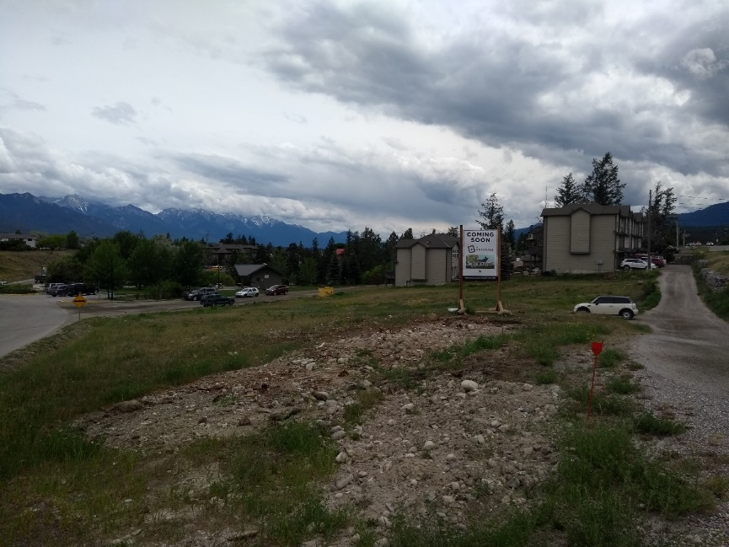

Generation Homes Ltd. is proposing to a build a 30-unit subsidized housing for locals at 606 10th Avenue, Invermere. The proposed development is located at the southeast corner of the 10th Avenue/5A Street intersection.

As part of the Development Permit application, Generation Homes requested to prepare a Traffic Impact Study (TIS) of the study area. The objectives of this study were to:

* Complete traffic counts at the study intersections of 10th Avenue/5A Street, 10th Avenue/5th Street, 9th Avenue/5A Street, as well as 7th Avenue/5A Street.
* Investigate the current traffic distribution along the study intersections during a.m. and p.m. peak hours using the newly obtained information;
* Determine and analyze the existing and projected traffic volumes resulting from the development, and evaluate their impacts on the study intersections for the a.m. and p.m. peak hours under 5-year horizon;
* Review the development’s access points to ensure ingress and egress are operating efficiently
* If required, identify and recommend appropriate infrastructure improvements necessary to accommodate the estimated traffic volumes;
* Review of the parking bylaw requirement and provision of the planned development; and,
* Consider pedestrian and cyclist connection to existing and future sidewalk pathways with reference to the District pathway and trail master plan

amica Lions Gate Expansion, Traffic Impact Study

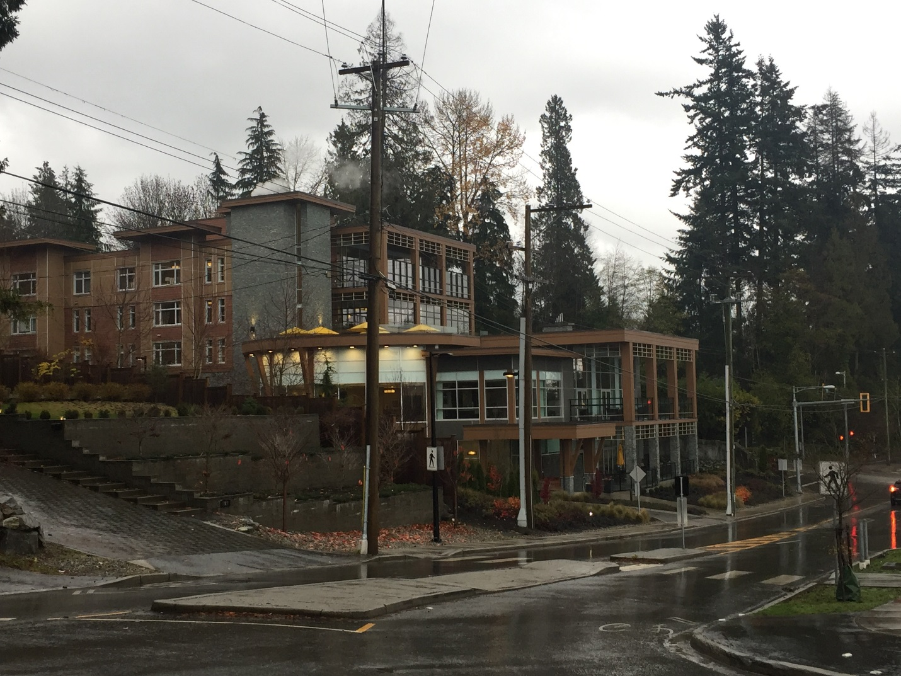

Milliken Real Estate Corporation proposed to build a 6-storey senior community development at 727 Keith Road, West Vancouver expanding the existing Amica Lions Gate Expansion. The proposed senior living facility is located on the north side of Keith Road just west of Taylor Way. It consists of a 5,620 sq.m building.

As part of the Development Permit application, Milliken Real Estate requested to prepare a Traffic Impact Assessment of the study area. The objectives of this study were to:

* Complete a traffic count on the existing site traffic as well as Taylor intersections with Keith Road, Esquimalt Avenue, and Evelyn Drive as well as the Keith Road/ Esquimalt intersection to identify the a.m. and p.m. peak-hour traffic volumes;
* Investigate the current traffic distribution along the study intersections during a.m. and p.m. peak-hour periods using the newly obtained information;
* Determine and analyze the existing and projected traffic volumes resulting from the development, and evaluate their impacts on the study intersections for the a.m. and p.m. peak hours under the 2027 and 2032 planning horizon traffic conditions;
* If required, identify and recommend appropriate infrastructure improvements necessary to accommodate the estimated traffic volumes;
* Provide safety recommendation improvements to the roundabout;
* Observe the Saturday midday peak hour (Park Royal Shopping Peak) traffic volumes.
* Review of the parking bylaw requirement and provision of the planned development; and,
* Review of existing issues of parked vehicles at Esquimalt Avenue affecting the roundabout traffic operation.